Thungela/Ensham Resources Manual
Site Visit Request System
Katlego Phoka
10-2-2025

Contents
Overview 2
SharePoint Environment 3
SharePoint Site 3
New site visit request 4
Assigned Requests 4
Site Content 5
Approving Manager Purpose 5
Adding a manager 6
Removing a Manager 6
Managing Security List 7
Adding a Security Contact 9
Removing a Security Contact 9

Overview
The Ensham Visitor system enables and facilitates site contacts to submit site visit requests.
Internal staff uses the system. The system contains an approval process for each submitted site visit request.
The system captures site contact details, visitor details and details of the visit.
A list of approving managers will be the only employees with the ability to approve site visit requests.
All related parties are updated, via email, on the status of the site visit request, as it progresses through its approval phase.
Purpose of this Manual:
This manual provides step-by-step guidance on how to use the Ensham Visitor system. It is intended for staff and site contacts who need to submit, review, approve, or manage site visit requests. The manual explains how to navigate the system, complete required forms, track approvals, and receive updates on request status.

SharePoint Environment

Environment | Purpose | Site
SharePoint Online Production | Production | https://thungela.sharepoint.com/sites/EnshamResources/enshamvisitors

SharePoint Site:
All information related to the Site Visit Request system is stored in lists on a SharePoint site. The sites are only accessible to internal staff. The page housing the app is the default page on the site. The app is only accessible to predetermined people and/or groups.

This is a sharePoint home app for Ensham Visitors
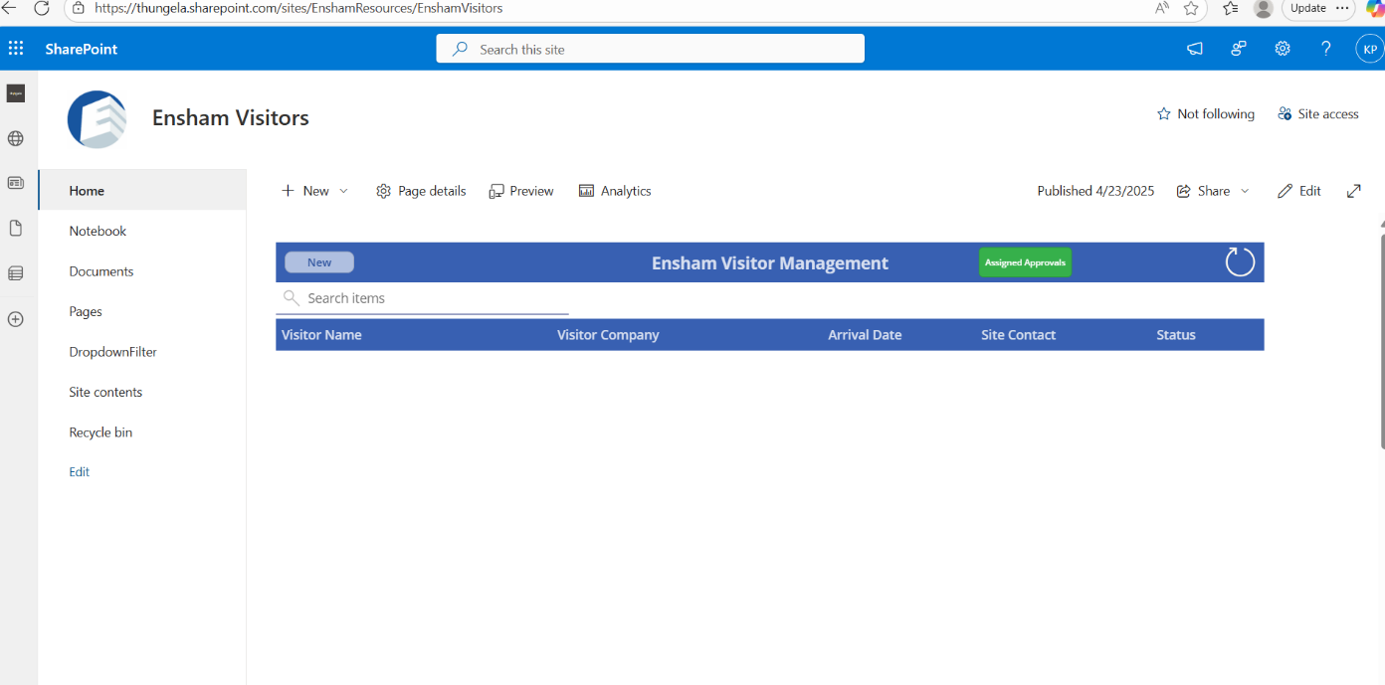

New site visit request:
- Click on New button on top left corner, fill in the form then press submit button to create a new site visit request
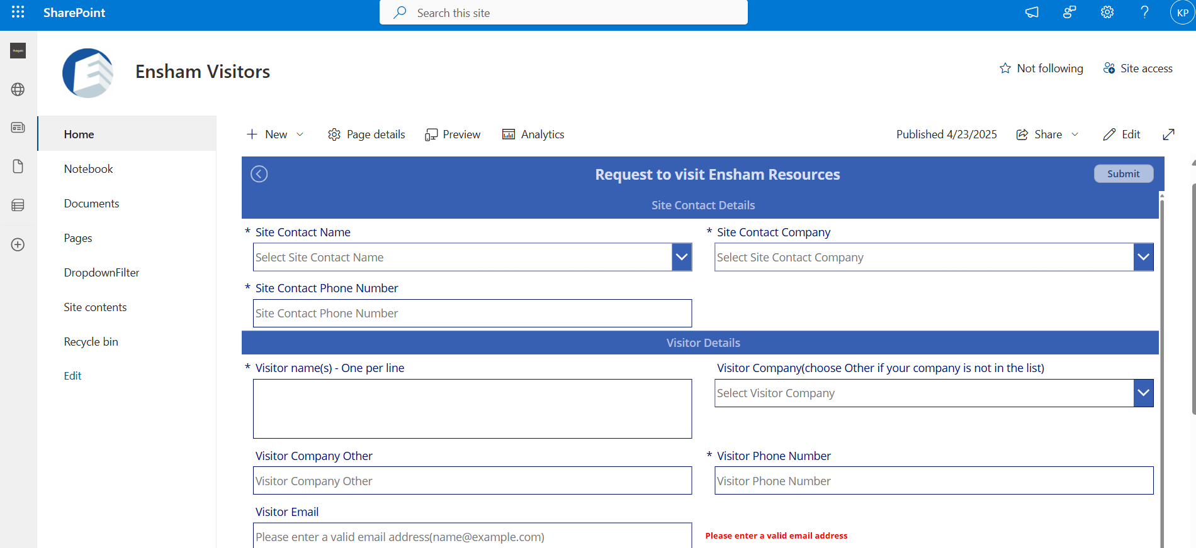

Assigned Requests
- When you click the Assigned button (green button top right), you will see all the site visit requests that require your approval.
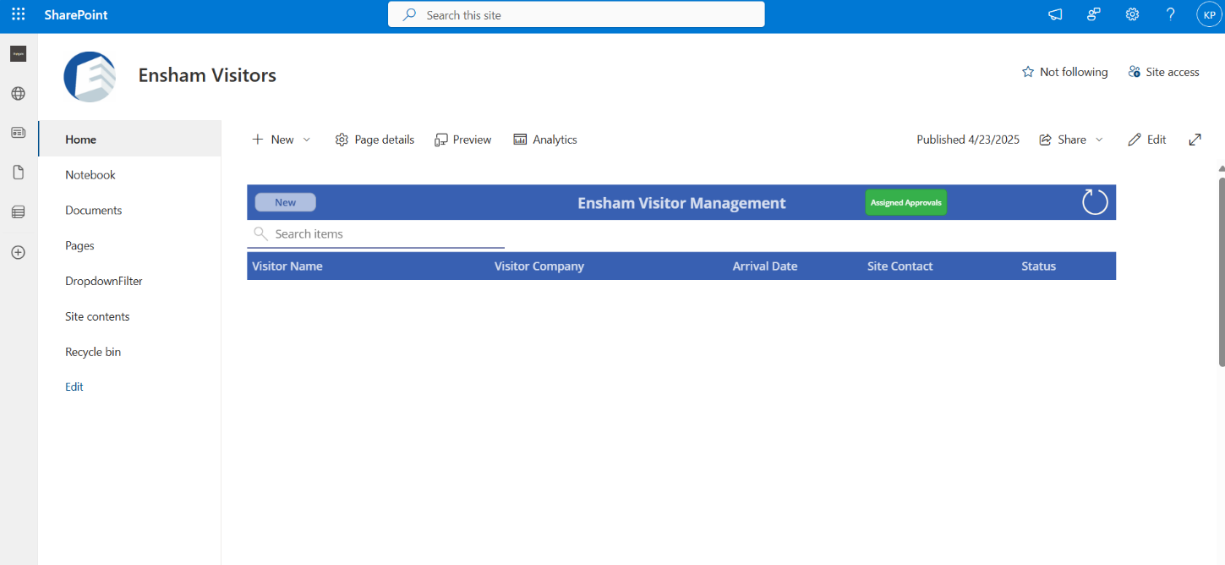

Site Content
- When you click Site Contents on the left-hand menu, you will see all the lists used in the system. These include the Security List, Site Visit List, and Approval Managers List.
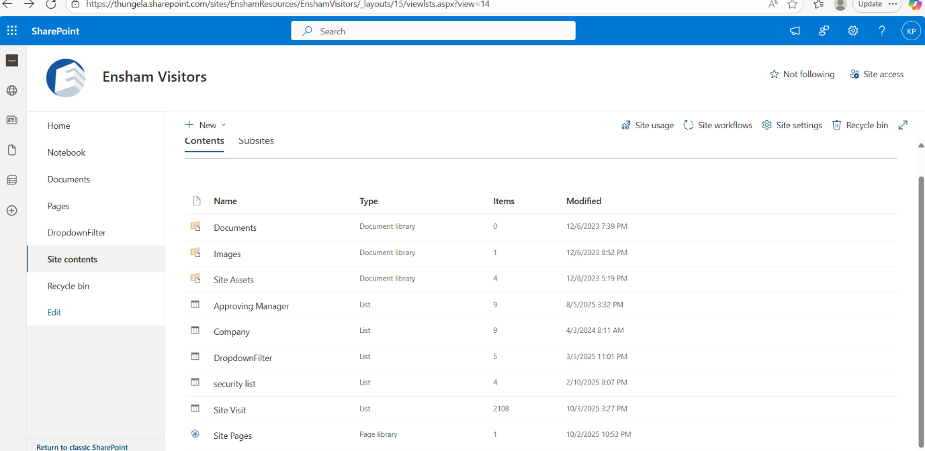

Approving Manager Purpose:
- The Approving Manager list holds the managers who could “Approve” or “Decline” site visit requests.
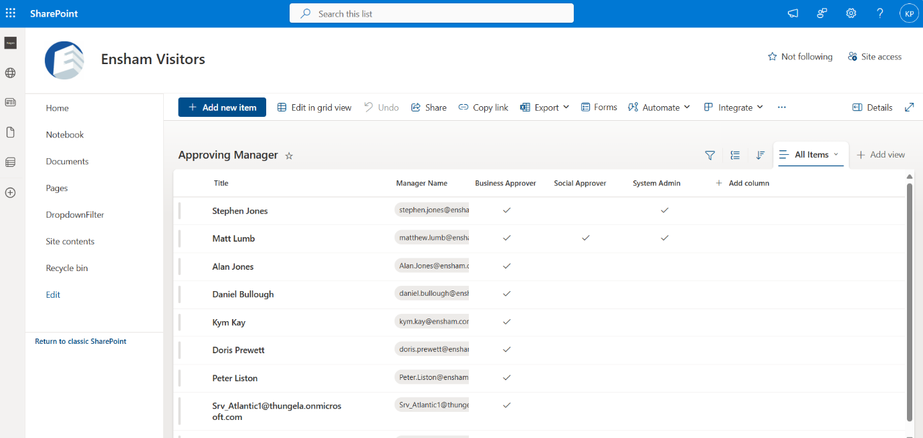

Adding a manager
- Navigate to Site Contents from the left-hand menu.
- Select Approving Manager.
- Click + Add new item at the top of the list.
- Enter the following details:
  - Title: Manager’s name
  - Manager Name: Manager’s email address
  - Select the appropriate checkboxes (Business Approver, Social Approver, System Admin) depending on the manager’s role.
- Click Save to add the manager.
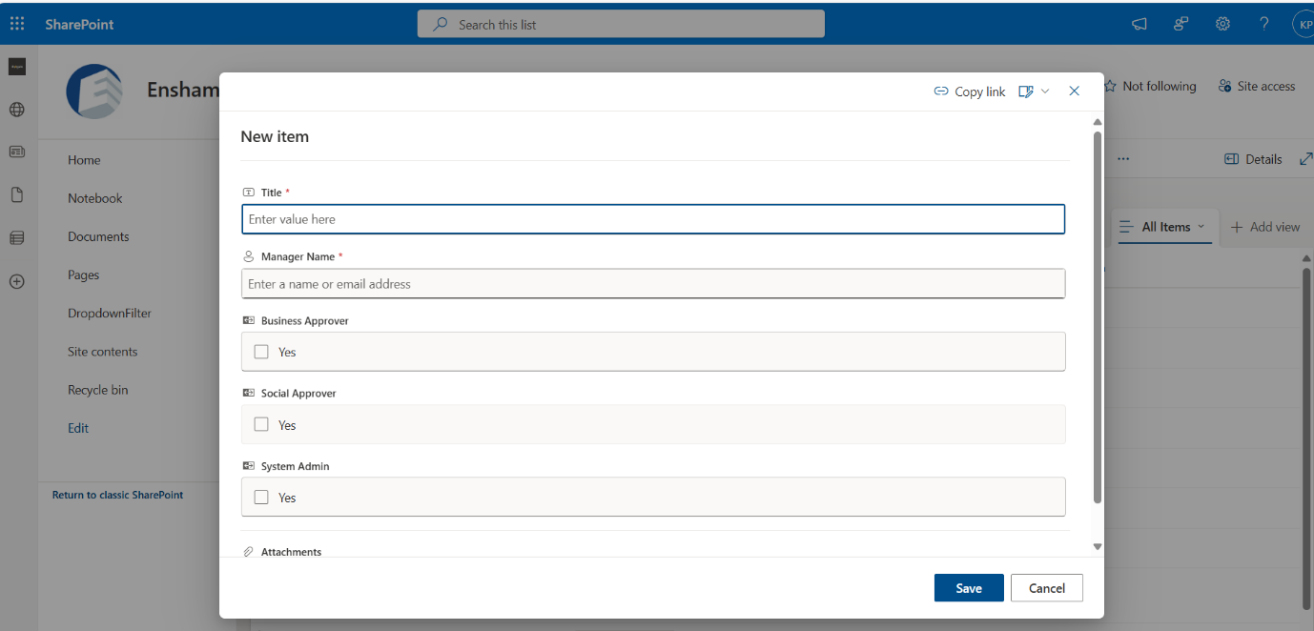

Removing a Manager
- Navigate to the Approving Manager list.
- Locate the manager you want to remove.
- Select the row by clicking next to the manager’s name.
- From the menu bar, click the Delete option.
- Confirm the deletion when prompted.
The manager will be removed from the list and will no longer have approval permissions.

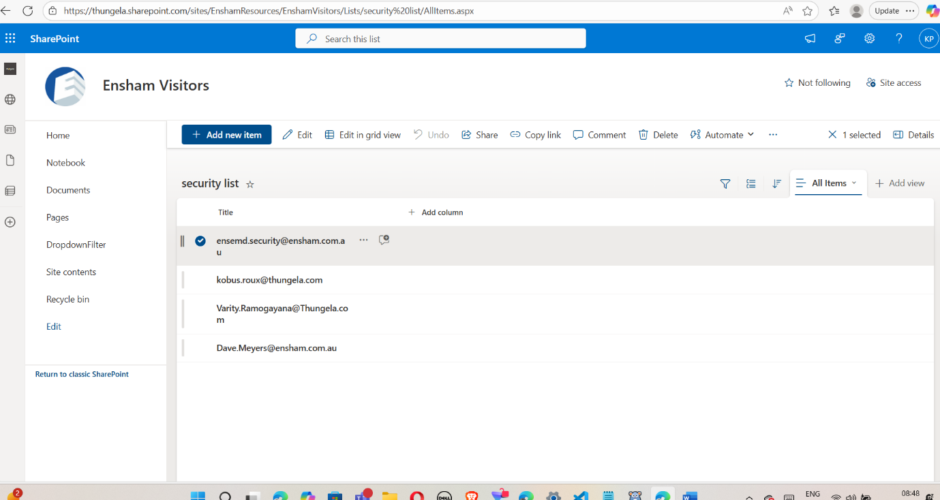

Managing Security List
The Security List contains all security contacts who will be notified about site visit requests. You can add or remove security contacts as needed
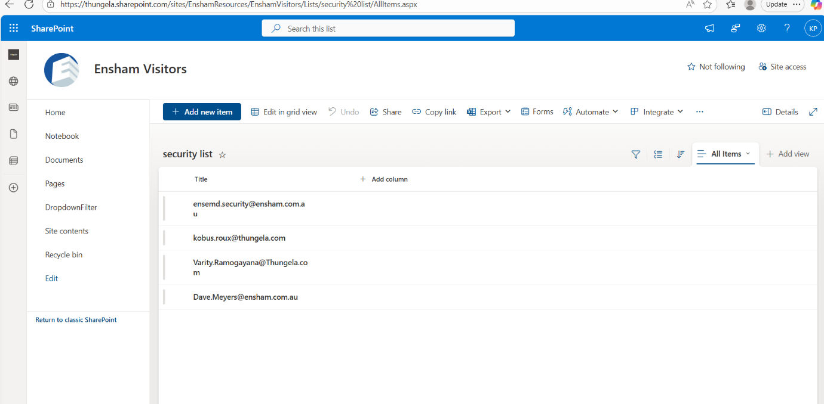

Adding a Security Contact
- Navigate to Site Contents from the left-hand menu.
- Select Security List.
- Click + Add new item at the top of the list.
- Enter the email address of the security contact in the Title field.
- Click Save to add the security contact.
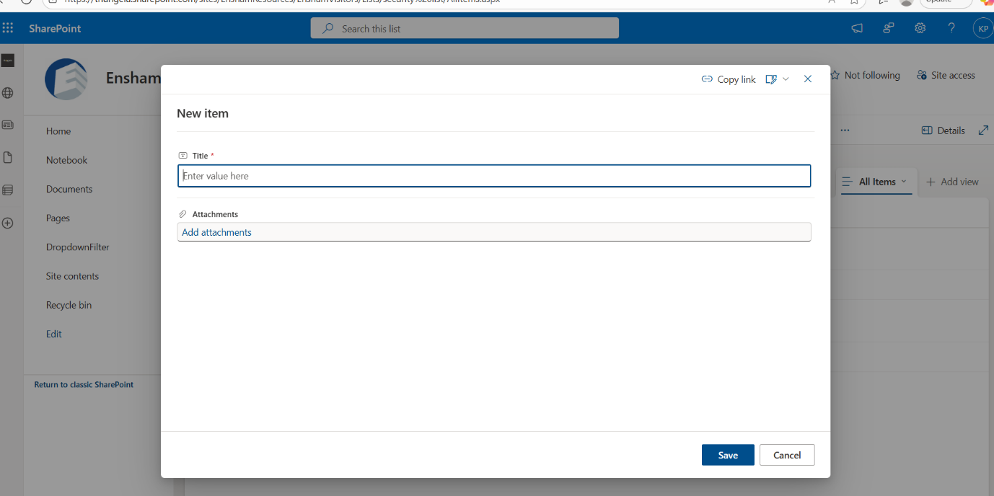

Removing a Security Contact
- Navigate to the Security List.
- Locate the contact you want to remove.
- Select the row by clicking next to the contact’s email.
- From the menu bar, click the Delete option.
- Confirm the deletion when prompted.
The contact will be removed from the security list and will no longer receive notifications.


